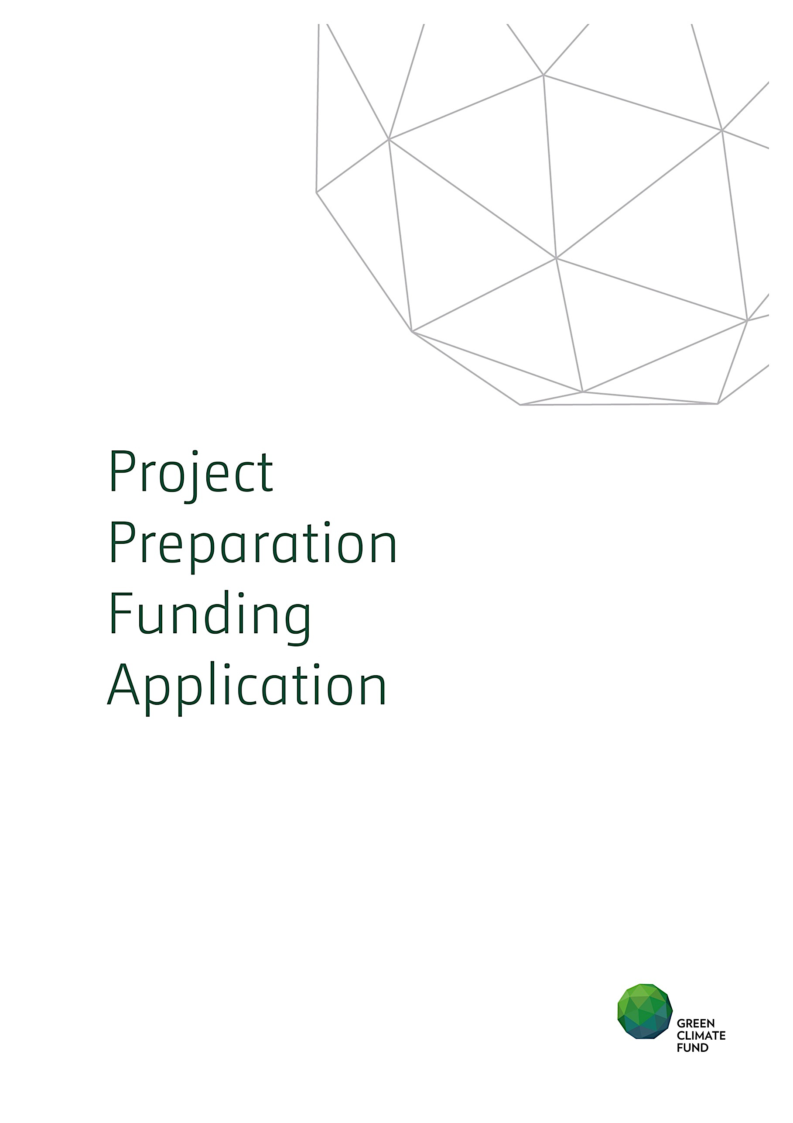

Application Title:
Country/ Region:
Accredited Entity:

TABLE OF CONTENTS

Section A EXECUTIVE SUMMARY
Section B DESCRIPTION OF ACTIVITIES
Section C RATIONALE
Section D IMPLEMENTATION PLAN
Section E FINANCING PLAN
Section F RISKS AND MITIGATION MEASURES

Please submit the completed form to:
ppf@gcfund.org

and use the following name convention for the file name:
“[PPF]-[Agency Short Name]-[Date]-[Serial Number]”

For more information regarding the PPF, please go to:
http://www.greenclimate.fund/partners/countries/fine-print

A. Executive Summary (in one page)
Accredited Entity
Contact Details | Name:  Position:  Email:  Tel:  Full Office address:
Concept Note Title
(reference number)
Country/Region
Request Summary
(in 200 words)

Anticipated Duration | DD/MM/YYYY – DD/MM/YYYY (total number of months)
Estimated cost | Total Cost: US$
 | Funding amount requested to GCF: US$

B. Description of Activities

C. Rationale
C.1 Background
Please provide country overview including initiatives related to climate finance e.g. NAMAs NAPs… etc.
C.2 Justification on request
Please provide rationale for GCF funding.

D. Implementation Plan
D.1 Implementation approach
Please include information on implementation arrangements.
D.2 Implementation schedule
D.3 Procurement Plan
Please provide detailed procurement plan including methods, terms of reference of consultancy services.

E. Financing Plan

F. Risk and Mitigation measures
Please describe the financial and operational risks and discuss mitigating measures.

Please briefly specify the substantial environmental and social risks that the readiness support may face and the proposed risk mitigating measures.

If a Concept Note has not been submitted for the underlying project for which the Project Preparation Grant is being requested, kindly complete the following sections.

Project / Programme Information
Project / programme title
Country (ies) / region
Mitigation / adaptation focus | Mitigation ☐ Adaptation ☐ Cross-cutting ☐
Results areas | Please list here the options from Annex - Table 1 that apply to this project/program
Project / programme description (including objectives)
Please describe briefly (up to 1 or 1.5 pages) the background, objectives, components and main activities of the proposed project/programme
Alignment with GCF Criteria
Please provide a short summary of alignment of this project/programme with GCF’s investment criteria
Brief Rationale for GCF Involvement and Exit Strategy
Please provide a short summary explaining why the GCF contribution is critical for the project/programme and how the project/programme sustainability will be ensured in the long run (after the project/programme is implemented with support from the GCF and other sources)
Financing/Cost Information
Details on financing sources:
FUNDING SOURCE | AMOUNT  (USD/EUR/JPY/GBP) | FINANCIAL INSTRUMENT  (Equity, loan, guarantee, grant) | Tenor | Pricing | Seniority
GCF financing |  |  | ( ) years | % | Options
Co-financing from AE |  |  | ( ) years | % | Options
Other (please specify name of institution) |  |  | ( ) years | % | Options
TOTAL PROJECT FINANCING
= Total project cost

Table 1. Results Areas
Which of the following targeted results areas does the proposed project/programme address?
Reduced emissions from:
☐ Energy access and power generation
(E.g. on-grid, micro-grid or off-grid solar, wind, geothermal, etc.)
☐ Low emission transport
(E.g. high-speed rail, rapid bus system, etc.)
☐ Buildings, cities, industries and appliances
(E.g. new and retrofitted energy-efficient buildings, energy-efficient equipment for companies and supply chain management, etc.)
☐ Forestry and land use
(E.g. forest conservation and management, agroforestry, agricultural irrigation, water treatment and management, etc.)
Increased resilience of:
☐ Most vulnerable people and communities
(E.g. mitigation of operational risk associated with climate change – diversification of supply sources and supply chain management, relocation of manufacturing facilities and warehouses, etc.)
☐ Health and well-being, and food and water security
(E.g. climate-resilient crops, efficient irrigation systems, etc.)
☐ Infrastructure and built environment
(E.g. sea walls, resilient road networks, etc.)
☐ Ecosystems and ecosystem services
(E.g. ecosystem conservation and management, ecotourism, etc.)

Table 2. Investment Criteria Guidance Notes
The following guidance note may help to present the potential of the Project/Programme to achieve the Fund’s six investment criteria.
D.1. Climate impact potential  [Potential to achieve the GCF's objectives and results] | Specify the climate mitigation and/or adaptation impact. Provide specific values for the below indicators and any other relevant indicators and values, including those from the Fund’s Performance Measurement Frameworks.  - Total tonnes of CO₂ eq to be avoided or reduced per annum  - Expected total number of direct and indirect beneficiaries and number of beneficiaries relative to total population (e.g. total lives to be saved from disruption due to climate-related disasters)
D.2. Paradigm shift potential  [Potential to catalyze impact beyond a one-off project or programme investment] | Provide the estimates and details of the below and specify other relevant factors.  - Potential for scaling-up and replication (e.g. multiples of initial impact size)  - Potential for knowledge and learning  - Contribution to the creation of an enabling environment  - Contribution to the regulatory framework and policies
D.3. Sustainable development potential  [Potential to provide wider development co-benefits] | Provide the estimates of economic, social and environmental co-benefits. Examples include the following:  - Economic co-benefits  - Total number of jobs created  - Amount of foreign currency savings  - Amount of government’s budget deficits reduced  - Social co-benefits  - Improved access to education  - Improved regulation or cultural preservation  - Improved health and safety  - Environmental co-benefits  - Improved air quality  - Improved soil quality  - Improved biodiversity  - Gender-sensitive development impact  - Proportion of men and women in jobs created
D.4. Needs of recipient  [Vulnerability to climate change and financing needs of the recipients] | Describe the scale and intensity of vulnerability of the country and beneficiary groups and elaborate how the project/programme addresses the issues. Examples of the issues include the following:  - Level of exposure to climate risks for beneficiary country and groups  - Does the country have a fiscal or balance of payment gap that prevents from addressing the needs?  - Does the local capital market lack depth or history?  - Needs for strengthening institutions and implementation capacity
D.5. Country ownership  [Beneficiary country ownership of project or programme and capacity to implement the proposed activities] | Provide details of the below and specify other relevant factors.  - Coherence and alignment with the country’s national climate strategy and priorities in mitigation or adaptation  - Brief description of executing entities (e.g. local developers, partners and service providers) along with the roles they will play  - Stakeholder engagement process and feedback received from civil society organizations and other relevant stakeholders
D.6. Effectiveness and efficiency  [Economic and financial soundness and effectiveness of the proposed activities] | Provide details of the below and specify other relevant factors (i.e. debt service coverage ratio), if available.  - Estimated cost per t CO2 eq (total investment cost/expected lifetime emission reductions)  - Co-financing ratio (total amount of the Fund’s investment as percentage of project)  - Economic and financial rate of return  - With the Fund’s support  - Without the Fund’s support

